|  |  |
| --- | --- |
| **DATE** |  |
| **SUBMITTED BY** | **VISHNUPRIYAN S** |
| **TITLE / ROLE** | **Online Voting System** |



**Use case diagram**

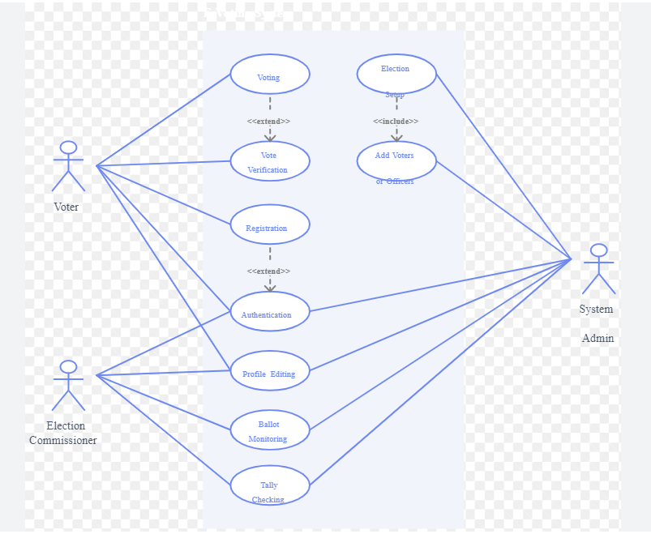

**ER Diagram**

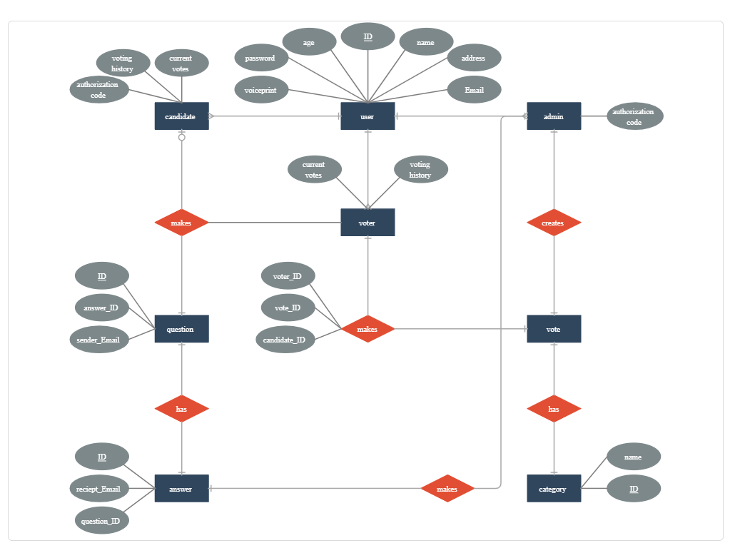

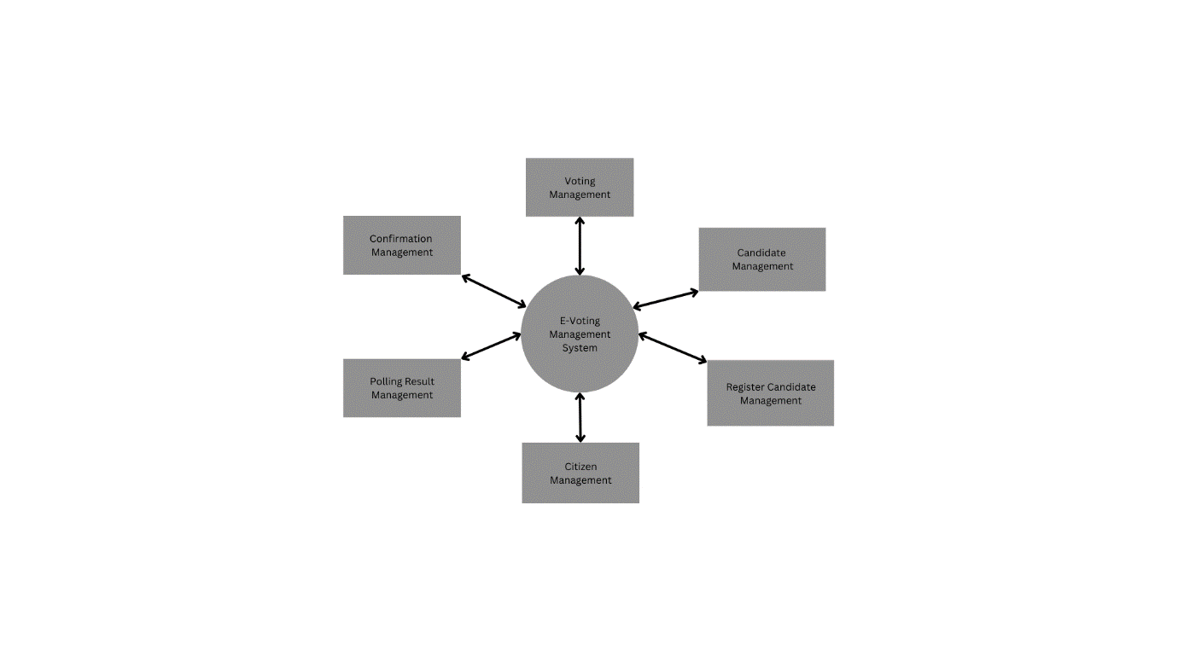**3.DFD Diagram process upto level 1 (LEVEL 0 DFD)**

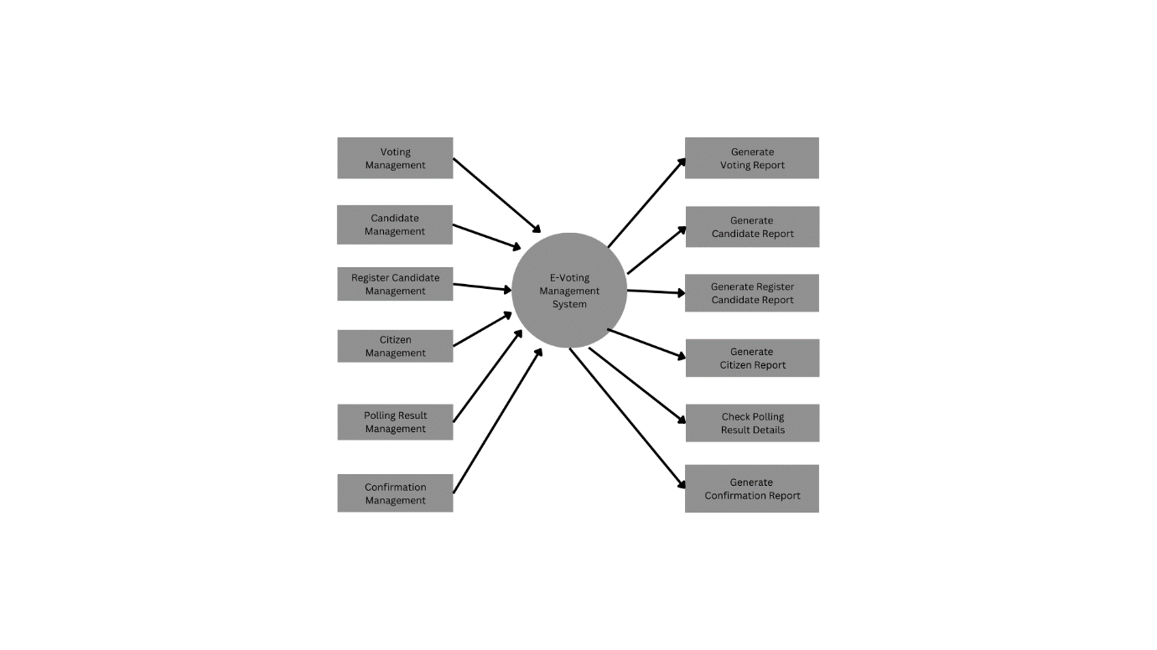**LEVEL 1 DFD**

**Class Diagram for online e-voting system**

